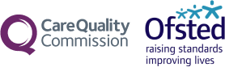

Area SEND inspection

Children and young people views

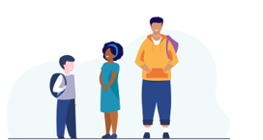
This survey is for children and young people between 11 to 25 years old with special educational needs and/or disabilities (SEND).

Please complete the survey online if you can.

You can find the online survey for your local area using this link https://ofsted.smartsurvey.co.uk/p/AreaSend/10414218


Hello
Inspectors from Ofsted and the Care Quality Commission (CQC) are coming to your area. They want to know about the support you get and how it has helped you. Your views are important to us.

You can tell them by filling out this survey. Please return your answers to data.areasend@ofsted.gov.uk by 3pm on 6 July 2026.

Please add Newcastle upon Tyne to the title of your email.

If you have difficulties using this survey, please email:
lasend.support@ofsted.gov.uk.
You can ask someone to email for you.

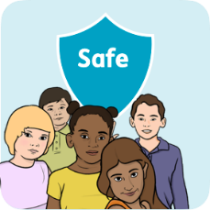
Safeguarding
Safeguarding is keeping people safe from harm and abuse.
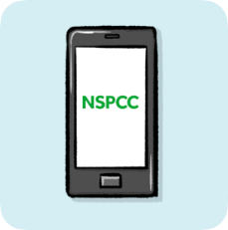

We will keep your answers private. We do not ask for your name. We may try to find out who you are if you tell us something that makes us worried about you or another person. We will tell the local council and health services if you tell us something that makes us worried.
If you want to speak to someone for advice you can call Childline on 0800 1111. If you are 18 or older you can call NSPCC on 0808 800 5000.

Your information
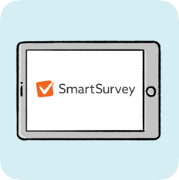
Ofsted uses machine learning to find themes in the survey answers. We will give the themes and answers to the inspectors so they can plan their work.

Machine learning gives data (information) to a computer so it can learn what to do by itself without being told.

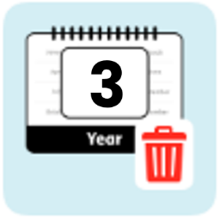
This survey is run by SmartSurvey. You can find out what they will do with your information here:
https://www.smartsurvey.co.uk/privacy-policy
SmartSurvey will delete your name and pass your information to Ofsted.
Ofsted will delete the information after 3 years.
This survey has been co-produced with easy-read-online.co.uk

About you


1. How old are you? (Please choose one)
Younger than 11 (please do not answer the rest of the questions. We can only save answers from children aged 11 and older)
11 – 15 (please answer question number 2, 3, 4, 5, 6, 7, 8, 23)
16 – 19 (please answer question number 9, 10, 11, 12, 13, 14, 15, 23)
20 – 25 (please answer 16, 17, 18, 19, 20, 21, 22, 23)

Questions 2-8 are for children aged 11-15 years.

2. Do people ask you what you want help with? (Please choose one)

 | Yes
 | No
 | Sometimes
 | I don’t know

3. Do you get the help you need for your health? (Please choose one)

Yes
No
Sometimes
I don’t know

4. Do you get the help you need for your learning? (Please choose one)

Yes
No
Sometimes
I don’t know

5. Are you learning things to help you in the future? (Please choose one)

Yes
No
Sometimes
I don’t know

6. Do you get help to do things outside of school? (Please choose one)

Yes
No
Sometimes
I don’t know

7. How could your help be better?

8. What help works well for you?

Questions 9 – 15 are for children and young people aged 16 to 19.

9. Do people ask you what you want help with? (Please choose one)

Yes
No
Sometimes
I don’t know

10 Do you get the help you need for your health? (Please choose one)

Yes
No
Sometimes
I don’t know

11. Do you get the help you need with your learning or at training?
(Please choose one)

Yes
No
Sometimes
I don’t know

12. Are you learning things to help you in the future? (Please choose one)

Yes
No
Sometimes
I don’t know

13. Do you get help to do things outside of school or your training?
(Please choose one)

Yes
No
Sometimes
I don’t know

14. How could your help be better?

15. What help works well for you?

Questions 16-22 are for 20 to 25 year olds

16. Do people ask you what you want help with? (Please choose one)

Yes
No
Sometimes
I don’t know

17. Do you get the help you need for your health? (Please choose one)

Yes
No
Sometimes
I don’t know

18. Do you get the help you need at college, training or work?
(Please choose one)

 | Yes
 | No
 | Sometimes
 | I am not in college, training or work
 | I don’t know
19. Are you learning things to help you in the future? (Please choose one)

Yes
No
Sometimes
I don’t know

20. Do you get help to do things outside of college, training or work?
(Please choose one)

Yes
No
Sometimes
I don’t know

21. How could your help be better?

22. What help works well for you?

Questions about you

23. Can you answer some more questions about you? We want to make sure that lots of different young people share their thoughts. We would like to ask you some questions about yourself, including about your sex, disability, sexual orientation and ethnicity.
 | Yes (please go to question 24)
 | No (finish the survey)

More questions about you
Please tell us a bit more about you. You do not have to answer these questions and you can choose ‘I prefer not to answer’ if you want to.

24. Do you consider yourself to have a disability? (You do not have to answer this question). (Please choose one)

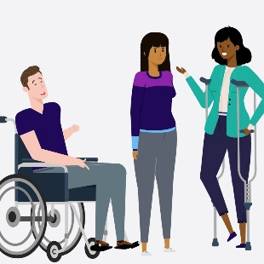

Yes
No
I prefer not to answer

25. Are you _______ (You do not have to answer this question)

(Please choose one)

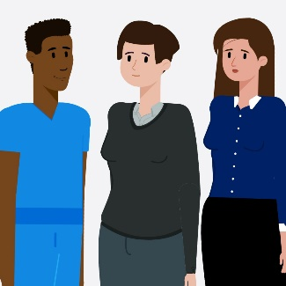
Male
Female
I prefer not to answer
Other sex (please write)

26. Which of the following best describes your sexual orientation? (You do not have to answer this question). (Please choose one)

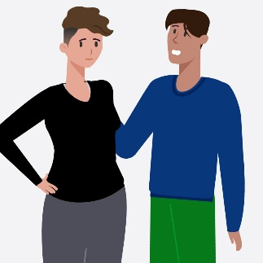

Straight or Heterosexual
Gay or Lesbian
Bisexual
I prefer not to answer
Other (please write)

27. How would you describe your ethnic group? (You do not have to answer this question). (Please choose one)

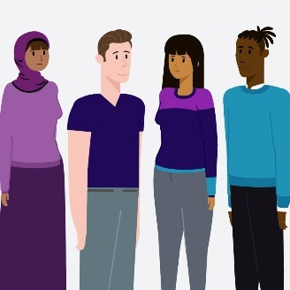
White
Black
Asian
Mixed
I prefer not to answer
Other ethnicity (please write)

