Newcastle Local Area
EHC decision making panels.
Terms of Reference.

April 2025
V2
Contents
Introduction 3
Summary of panels 4
EHC Assessment request panel: Children and young people, age 0-25 5
EHC Outcome and Review Panel: Children and young people, age 0-25 8
EHC Funding Panel: Children and young people, age 0-25 13
EHC Annex 1 Panel: Children and young people, age 0-25 15
Supporting the panels 17
Communicating the outcomes 17
Confidentiality 17
Review 17
Appendix 1 Education, Health, and Care Plan Workflow 18
Appendix 2 Panel Decision Guide 19
Appendix 3 Management decision outside of EHCP Panel form 21
Appendix 4 Panel Discussion Framework 22
Appendix 5 – EOTAS Checklist 25
Appendix 6 - High Needs Funding Form – Annex 1 25

Introduction

Newcastle City Council (the LA) is responsible for considering requests for a statutory assessment of a child/young person’s special educational needs and/or disabilities (SEND). As well as undertaking these assessments, monitoring, and reviewing all Education, Health, and Care Plans (EHCPs) for children and young people aged 0-25. To do this, it is good practice to establish multi-agency panels which ensure a joint collaborative approach to support the LA in making transparent and equitable well-informed decisions. The members of the panel will consider whether the Graduated Response process has been followed; and the Universally Available Provision and Descriptors of Need have been used to support the child at a SEN Support Level, before deciding if the needs are above and beyond what would normally be expected in an education setting.

To ensure fairness and equity in decision-making, the panel will base its recommendation solely on the written documentation provided as part of the assessment process or submitted during the annual review process and shared with them. Additionally, all parties with a vested interest in the outcome are expected to declare on interest and refrain from introducing any new information during the panel discussion.

The main role of the panels is to consider a range of LA statutory duties, requirements and related matters including:

Education, Health, and Care (EHC) requests:
Based on the information and evidence provided decide whether an EHC needs assessment should proceed.
Provide advice and guidance around other support that may be available to schools/settings if it is decided that an EHC needs assessment will not proceed.

Decide the outcome of an EHC needs assessment:
Based on all the information and additional evidence gathered from multi-agencies, decide if an EHC Plan is required.
Provide advice and support, if it is agreed that an EHC Plan is not required, and support can be provided at SEN Support level.

Annual Reviews:
Requests for changes of types of provision i.e., from mainstream to specialist.
Recommend type of suitable provision for an upcoming Age phased transfers.
Consider a request for a Personal Budget.
Consider request for increased funding or high-cost placement requests.

Children and young people transferring into Newcastle:
Consider taking over responsibility of an EHCP.
Agree to continue with a statutory EHC Assessment.
Recommend type of educational provision.
Recommend a funding banding.

High-Funding Requests:
Consider requests made by schools for funding over Band G.
Consider whether high-cost placement is an efficient use of public resources, whilst considering all other viable options.
Make recommendations on whether funding is being used effectively by settings to meet needs.

Annex 1 Requests:
Consider requests for additional funding from FE providers.

In advance of all panel meetings, it is expected that all members will have read the panel papers and noted their views, initial thoughts, and recommendations, highlighting any areas for specific discussion.

Decisions are communicated with parents and school following a panel meeting. Information is included about how parents can appeal the decisions made.

Summary of panels
EHCP 0-25  New Assessment Request Panel | EHCP 0-25  Outcome and Review Panel | EHCP 0-25  G+ Funding Panel | EHCP 0-25  Annex 1 Panel
Chair – SEND SAR Team Manager/Senior Practitioner | Chair – SEND SAR Team Manager/EP Manager/Senior EP | Chair – SEND Service Manager | Chair – PfA Lead
Wednesday PM Weekly  60 minutes | Wednesday AM Weekly  150 minutes | Tuesday PM – Fortnightly  90 minutes | Wednesday PM – Weekly  120 minutes
Aim  Discuss the evidence submitted to decide if the threshold has been met to carry out a statutory assessment for an EHC Plan. | Aim  Make decisions about whether a plan should be issued.  Recommendations on the type of setting appropriate.  Suggest level of funding to meet needs.  Change of placement/funding  Personal budget requests.  EOTAS Requests  Cease Plans  To consider high-cost independent places | Aim  To consider requests made for funding requests which exceed Band G funding.
  Aim
  To consider requests for additional funding from FE providers.

EHC Assessment request panel: Children and young people, age 0-25
Purpose
To consider all requests for a statutory Education, Health and Care assessment and decide whether there is enough evidence to meet the required threshold for an assessment to be undertaken.

When it is agreed to undertake a statutory assessment, as a minimum the following will be requested to contribute to the assessment and provide a report/advice:

- Educational setting (if further information is required in addition to application)
- Parents views
- Child/young person’s views
- Educational Psychologist (LA)
- Social Care
- Dedicated Medical Officer
- Any other as identified by parent and/or panel recommendation

Scope of the panel
To consider whether the Graduated Response process has been followed and if there is sufficient evidence to support the request, which demonstrates that despite relevant and purposeful action to identify, assess and meet the special educational needs of the child or young person, expected progress has not been made. The members of the panel will consider whether support from outside agencies, such as SEN Advice and Support Panel (ASAP) have been sought and the recommendations implemented for a sufficient period. As well as whether the Universally Available Provision and Descriptors of Need have been used to support the child at a SEN Support Level, before deciding if the needs are above and beyond what would be expected in an education setting.

To do the above panel will apply the Panel Decision Guide

Where International new arrivals (INA) have been identified, an assessment request will be processed and discussed during this panel meeting.

Capped case numbers
To ensure there is sufficient time to discuss all the cases presented and allow robust decisions to be made, cases will be capped at 20. Where timescales will be negatively impacted, this will be reviewed on a week-by-week basis.

Quorum

The panel chair holds the responsibility of determining whether the panel is quorate, this will ensure robust decision making. To be quorate, at least one representative must be present from each of the following key teams: Newcastle SEND (Special Educational Needs and Disabilities), Educational Psychology, Social Care, and Health .This multi-disciplinary representation is essential to ensure that a comprehensive range of perspectives and expertise is available when discussing each case.

If, for any reason, the panel is unable to meet the necessary quorum due to the absence of a representative from one or more of the required teams, the affected/pertinent cases scheduled for discussion during that session will be deferred to the next available panel meeting.

During term time, school representatives are expected to be available and to participate in panel discussions, sharing their insights and opinions on cases where relevant. It is also essential that there are representatives from specialist and mainstream schools as well as a mix of primary and secondary specialists. It is however important to note that the attendance of school representatives is not mandatory during school holidays, even if the panel is scheduled to go ahead. This flexibility allows the panel to continue operating during periods when schools are not in attendance without putting undue pressure on school staff.

In rare or exceptional circumstances, if the chair determines that there is insufficient representation for the panel to function effectively e.g. no representation from a key stakeholder or group of stakeholders— meaning that the panel cannot proceed with a fair or informed discussion due to missing expertise or input — those cases will be rescheduled to the next panel in their entirety. These deferred cases will be given priority at the following meeting to ensure that they are dealt with in a timely manner.

Exceptions
There is a recognition that there will be times that decisions will need to be made outside of the EHC Panel’s scheduled meetings, to ensure that provision for a child or young person’s needs are considered urgently.
For information and transparency, any decisions made outside of the EHC panel framework will be submitted by the SEN Caseworker. A Decision made outside of EHCP panel document and submit it to the SAR Manager or Senior Practitioner to agree. Once this is returned, the document MUST be uploaded to Capita. This will include decisions made following Mediation or Tribunal.
During the school holidays, panel meetings will be avoided if possible unless this will exceed statutory timescales.

Meetings
Every Wednesday 2pm – 3pm: Microsoft Teams.
Service | Role
Chair | Remind panel members of their duties and responsibilities to ensure that decisions made are in accordance with the requirement of the SEND Code of Practice.  Where there is a difference of opinion, have the final vote to determine a decision/action on behalf of panel.  Arrange for cases to be re-considered when necessary.  Approve the minutes and action sheets from the panel. | SEND Support Assessment and Review Manager or a Senior Practitioner
Educational Psychologist | Provide views, recommendations and opinions on Education needs as well as agree appropriateness for a Newcastle or Skylake assessment. | Member of Newcastle EPS
Social Care | Provide views, recommendations and opinions on perceived social care needs. To give additional information relating to social care involvement and follow up any queries. | DSCO or Family Support Worker
Medical Representative | Provide views, recommendations and opinions on health needs and how these may be presenting.  Based on the information provided, consider any additional health teams/services that it would be appropriate to ask to contribute to a statutory EHC assessment. | Dedicated Medical Officer
School Representatives | To provide views and opinions on use of graduated response and universally available provision within a school setting. | Primary and Secondary Mainstream representatives
Senior Practitioners | Provide their views and opinions relating to EY to NCY 8 cases. | SEND Senior Practitioners
PFA Leads | Provide their views and opinions relating to year 9+ cases | Preparing for Adulthood leads
Service Improvement Assistant | The panel will be supported by a Service Improvement Assistant who will maintain agenda and minutes of the meetings. | Service Improvement Assistant
Other
Observers | For personal development and knowledge building.
Accountability
The EHC request panel will report performance to the ‘‘Joint Intelligence and Commissioning’ workstream and the ‘Getting it Right Together’ workstream who will in turn escalate issues where appropriate to the SEND Executive Board.

EHC Outcome and Review Panel: Children and young people, age 0-25
Purpose
To make decisions about the outcomes following statutory assessment.
To make decisions of any proposed changes made following an annual or interim review.
To ensure that Newcastle’s decisions are transparent, consistent, and fully compliant with all legal requirements.¹
Scope of the panel
Where possible Panel members will use the Panel Discussion Framework to facilitate structured discussions about each case presented.

On receipt of assessment advice:

- Recommend if an EHCP is required.
- Recommend a type of educational provision i.e., mainstream or specialist.
- Recommend level of High Needs Top-up funding to be allocated.
- Provide advisory actions for education providers and other services.
- If there is a decision not to proceed to issue a draft EHC Plan, provide advice and recommendations for a SEN Support Plan.
- Refer children/young people in our care (CIC) who require a joint residential package of education, health and care to the Social Care Resource and Care Panel. If necessary, all relevant stakeholders will be contacted for their views prior to panel.

Consider requests from an interim age phase or annual EHC Review and:

- Consider change of placement (CoP) requests.
- Consider increased funding requests.
- Consider placements, needs and provision for pupils at Age Phase Transfer stage.
- Recommend if an EHCP should be ceased, where outcomes have been met.
- Determine and agree funding in relation to a personal budget for EHC elements when requested.
- Consider Education Other than at School (EOTAS) requests – panel will be asked to determine is a child or YP reaches the threshold for EOTAS.

Transfer in:
- Determine whether an adoption of an EHC Plan is appropriate.
- Consider whether Newcastle take responsibility to continue with a statutory assessment that has already started.
- Consider the needs of children and young people who have moved into the Newcastle local area and make recommendations on the type of placement which is most appropriate.
- Make decision to reassess if appropriate.

Any other business
At times, the EHC Panel will be asked to offer advice and recommendations to support a CYP with an EHCP. This may also include:

Reconsideration of recommendations made around placement and funding bandings when presented with updated evidence of support.

This could include, but not be limited to,
- Requests for additional funding following consultation with a school.
- Consideration for Independent Specialist places when no other setting is appropriate.

Any other requests.

Capped case numbers
To ensure there is sufficient time to discuss all the cases presented and allow robust decisions to be made, cases will be capped at 45. Where timescales will be negatively impacted, this will be reviewed on a week-by-week basis.

Quorum
The panel chair holds the responsibility of determining whether the panel is quorate, this will ensure robust decision making. To be quorate, at least one representative must be present from each of the following key teams: Newcastle SEND (Special Educational Needs and Disabilities), Educational Psychology, Social Care, and Health. This multi-disciplinary representation is essential to ensure that a comprehensive range of perspectives and expertise is available when discussing each case.

If, for any reason, the panel is unable to meet the necessary quorum due to the absence of a representative from one or more of the required teams, the affected/pertinent cases scheduled for discussion during that session will be deferred to the next available panel meeting.

During term time, school representatives are expected to be available and to participate in panel discussions, sharing their insights and opinions on cases where relevant. It is also essential that there are representatives from specialist and mainstream schools as well as a mix of primary and secondary specialists. It is however important to note that the attendance of school representatives is not mandatory during school holidays, even if the panel is scheduled to go ahead. This flexibility allows the panel to continue operating during periods when schools are not in session without putting undue pressure on school staff.

In rare or exceptional circumstances, if the chair determines that there is insufficient representation for the panel to function effectively e.g. no representation from a key stakeholder or group of stakeholders— meaning that the panel cannot proceed with a fair or informed discussion due to missing expertise or input — those cases will be rescheduled to the next panel in their entirety. These deferred cases will be given priority at the following meeting to ensure that they are dealt with in a timely manner.

Exceptions
There is a recognition that there will be times that decisions will need to be made outside of the EHC Panel’s scheduled meetings, to ensure that provision for a child or young person’s needs are considered urgently.
For information and transparency, any decisions made outside of the EHC panel framework will be submitted by the SEN Caseworker. A Decision made outside of EHCP panel document and submit it to the SAR Manager or Senior Practitioner to agree. Once this is returned, the document MUST be uploaded to Capita. This will include decisions made following Mediation or Tribunal.
During the school holidays, panel meetings will be avoided if possible unless this will exceed statutory timescales.

Meetings
Every Wednesday 9.30 – 12 via Teams
Service | Role
Chair | Role  Remind panel members of their duties and responsibilities to ensure that decisions made are in accordance with the requirement of the SEND Code of Practice.  To ensure the Panel Discussion Framework is used to facilitate structured discussions about each case presented.  Where there is a difference of opinion, have the final vote to determine a decision/action on behalf of panel.  Arrange for cases to be re-considered when necessary.  Approve the minutes and action sheets from the panel.  To ensure the correct wording is used when disagreeing to issue an EHCP. This will be used on the letters sent to parents.  When EP representative is in the Chair role, no SAR Team manager will be present. | On a rotation basis - Support, Assessment and Review Team Manager/ Educational Psychology Team Manager or Deputy Manager
Educational Psychology Service | Provide professional advice and guidance.  Discuss the details of EP assessments undertaken.  Consider new requests for an Educational Psychologist (EP) assessment.  Consider requests for an EP re-assessment where appropriate.  Consider consultation responses.  Provide support and advice (regarding ongoing assessments).  When EP representative is in the Chair role, no additional EP representative will be present. | Educational Psychology Team Manager or Deputy Manager
Health  . | Role  The Dedicated Medical Officer (DMO) sits on the EHC Panel and represents health and therapy services.  The Dedicated Clinical Officer (DCO) from the ICB can support schools with their duties under the ‘Supporting Pupils with Medical Conditions’ guidance.  The DMO and DCO have delegated responsibility on behalf of the ICB to make key decisions i.e., agreeing the health services in an EHC plan:  Consider the appropriateness of health requests/provision to be detailed in an Education, Health, and Care Plan  Be part of the decision making on panel  Be a point of contact outside of panel if there are any concerns.  Consultant Paediatrician  To provide professional advice and guidance.  Specialist Nurses  To provide professional advice and guidance. | Nurse coordinator for ICB
SENDOS | Provide views and opinions on SENDOS input from specialist teachers. | SENDOS Team
Education | Provide professional advice and guidance within area of expertise.  Provide educational advice, support, and recommendations to the EHC Panel. | Primary Mainstream Representative  Secondary Mainstream Representative  ARP Representative  Primary Specialist Representative  Secondary Specialist Representative
Social Care | Consider the appropriateness of social care requests/provision to be detailed in an Education, Health, and Care Plan.  Be part of the decision making on panel.  Be a point of contact outside of panel if there are any concerns.  Should any concerns be discussed at the EHC Panel regarding a child that is active to social care/ Early Help, the Social Care representative who attends the EHC Panel meetings will raise this with the allocated social worker. | Designated Social Care Officer (DSCO)  Adult social care to be invited as required.  Children with Disabilities Team to be invited as required  Early Help to be invited as required
Senior Practitioners | Provide their views and opinions relating to EY to NCY 8 cases. | SEND Senior Practitioners
PFA Leads | Provide their views and opinions relating to year 9+ cases | Preparing for Adulthood leads
EOTAS Caseworker | When EOTAS cases are presented, the SEN Caseworker responsible for EOTAS caseload will attend panel to ensure all considerations are given to enable an EOTAS Package to be robustly agreed or disagreed. | SEN Caseworker
Placement Planning | For awareness and to ensure robust placement planning and consultations. To offer advice on available school placements. To follow up on any recommendations relating to placement discussions. | Placement Planning Officers
Observers | For personal development and knowledge building.
Service improvement assistant | The panel will be supported by a Service Improvement Assistant who will maintain agenda and minutes of the meetings. | Service Improvement Assistant
Accountability
The EHC Outcome and Review panel will be reporting performance to the ‘Joint Intelligence and Commissioning’ workstream and the ‘Getting it Right Together’ workstream who will in turn escalate issues where appropriate to the SEND Executive Board.

EHC Funding Panel: Children and young people, age 0-25
Purpose
To consider funding requests which are above Band G.

Scope of the panel
The panel will:

- For pre-16 this panel will consider requests for additional funding, which falls above £13,300 in mainstream and Additionally Resourced Provisions and above £14,000 for Specialist Schools, to support the child or young people.
- For post-16 this panel will consider requests for additional funding, which falls above £14,000 in post 16 mainstream provisions and above£18,000 for post 16 Specialist provisions, to support the young people.
- For those who are agreed an EOTAS package, this panel will discuss the details of the personal budget to provide the provision outlined in the section F.
- For those who are requesting Independent Specialist provision, this panel will consider if the request is appropriate, and the costings are in line with Newcastle’s commissioning agreements. They will also consider all the steps which have been explored to meet the needs of the child or young person in a Newcastle maintained setting.
- For children in the care of another LA ensure that financial responsibilities are clear
- Identify cases that may require consideration at the Children’s Continuing Care Panel. If necessary, all relevant stakeholders will be contacted for their views prior to panel.
- For standard 1:1 funding requests, where the evidence supports this request, the LA agree that standard costs to fund 32.5 hours, will be £27,024 for special, and £18,493 for mainstream and ARP’s (SEND Notional has already been deducted).

To help with deliberations panel members will be provided with but not limited to:
- A SEN Caseworker summary which clearly indicates what is being requested.
- A Costed Provision Map aligned with section F of the EHCP or an Annex 1 form (post 16)
- A copy of the EHCP
- Minutes from EHC Panel where members have made a recommendation on whether they feel funding is appropriate.
- Minutes of the review meeting
- Reports and evidence to support the request.
- Copies of all consultation responses, where requests for funding for new starters have been made through the consultation process, where schools feel that funding exceeding Band G is required.

Exceptions
There is a recognition that there will be times that decisions will need to be made outside of the EHC Panel’s scheduled meetings, to ensure that provision for a child or young person’s needs are considered urgently.

For information and transparency, any decisions made outside of the EHC panel framework will be submitted by the SEN Caseworker. A Decision made outside of EHCP panel document must be completed by the SEN Caseworker with the agreement of the SAR Manager or Senior Practitioner; it must then be passed to the SEND Team Manager for agreement. Once this is returned, the document MUST be uploaded to Capita. This will include decisions made following Mediation or Tribunal.

During the school holidays, panel meetings will be avoided if possible.

Quorum
Funding panel will not go ahead unless the chair, SEND and Finance representatives are available.

Meetings
As required to align with the needs of the service
Service | Role
Chair | Remind panel members of their duties and responsibilities to ensure that decisions made are in accordance with the requirement of the SEND Code of Practice.  Where there is a difference of opinion, have the final vote to determine a decision/action on behalf of panel.  Arrange for cases to be re-considered when necessary.  Approve the minutes and action sheets from the panel. | Head of SEND
SEND Representation | Provide views and opinions on placement options, contents of the EHCP and the appropriateness of the costings requested in relation to the plan. To feedback any queries SEN Caseworkers may have around decisions. | SEND SAR Manager/SEND Senior Practitioner
Finance Representation | Provide views and opinions on financial decisions around costing rates. | Education Funding Specialist
Commissioning Representative | Evaluate funding matrices received from independent specialist schools though the commissioning process to ensure the requested costings are appropriate. | Procurement/Commissioning Lead
SEND Place Planning | Provide views and opinions on consultation responses received from schools. | SEND Place Planning Officer
Service Improvement Assistant | To maintain agenda and minutes of the meetings. | Service Improvement Assistant
Other
Observers | For personal development and knowledge building.
Accountability
The EHC funding panel will be reporting performance to the ‘Joint Intelligence and Commissioning’ workstream and the ‘Getting it Right Together’ workstream who will in turn escalate issues where appropriate to the SEND Executive Board.

EHC Annex 1 Panel: Children and young people, age 0-25
Purpose
To consider high needs funding requests from post 16 providers.
This will be done through the submission of an Annex 1 form and Costed Provision Map.

Scope of the panel
The panel will:

Assess the high needs funding application against the identified provision outlined in section F of the EHC plan.

Consider any further evidence presented relating to this request.

Make recommendations around the appropriateness for costed provision maps and identify which need to be referred to funding panel for final decision.

Make counter proposals to post 16 providers to explore how needs can be met.

- Where funding requests for mainstream post 16 education are above £14,000 (Element 3), recommendations will be made to the appropriateness of the request but will be considered further at EHCP Funding Panel.

- Where funding requests for specialist post 16 education are above £18,000 (Element 3), recommendations will be made to the appropriateness of the request but will be considered further at EHCP Funding Panel.

Exceptions
There is a recognition that there will be times that decisions will need to be made outside of the EHC Panel’s scheduled meetings, to ensure that provision for a child or young person’s needs are considered urgently.
For information and transparency, any decisions made outside of the EHC panel framework will be submitted by the SEN Caseworker. A Decision made outside of EHCP panel document and submit it to the SAR Manager or Senior Practitioner to agree. Once this is returned, the document MUST be uploaded to Capita. This will include decisions made following Mediation or Tribunal.
During the school holidays, panel meetings will be avoided if possible.

Quorum
To ensure that the panel is quorate, the chair must be able to demonstrate that there is sufficient attendance to enable robust decisions to be made.

Meetings
Every Wednesday 3 – 5 pm
Service | Role
Chair | Remind panel members of their duties and responsibilities to ensure that decisions made are in accordance with the requirement of the SEND Code of Practice.  Where there is a difference of opinion, have the final vote to determine a decision/action on behalf of panel.  Arrange for cases to be re-considered when necessary.  Approve the minutes and action sheets from the panel. | Preparation for Adulthood Lead
Adult Social Care
Health
EPS | Educational Psychologist
Service Improvement Assistant | The panel will be supported by a Service Improvement Assistant who will maintain agenda and minutes of the meetings. | Service Improvement Assistant
Other | EPS | EPS representative
Observers | For personal development and knowledge building.
Accountability
The EHC Annex 1 Panel will be reporting performance to the ‘Joint Intelligence and Commissioning’ workstream and the ‘Getting it Right Together’ workstream who will in turn escalate issues where appropriate to the SEND Executive Board.

Supporting the panels
All panels will be supported by a Service Improvement Assistant who will distribute the agenda and supporting documents, record the decisions made, and distribute the minutes once they have been reviewed. The SIA will save a copy of the minutes to the appropriate folder and upload the information to the Activity section in Capita.

All relevant information will be shared by the SIA with panel members electronically before every panel meeting. This will include all the necessary paperwork received to support the decision-making process.

For EHCP Assessment and Outcome and Review panels, these agendas will be sent out 4 working days before the panel date to ensure enough time is available to consider the documentation. To ensure this is possible, no more agenda items will be added from 12 noon on the Wednesday before the panel date.

Papers will be treated in utmost confidence and any printed papers will be destroyed securely following the meeting.

Communicating the outcomes
Once the panel minutes are checked and distributed, the SEN caseworker must communicate the outcome to the school. The outcomes of these panels must be communicated in a timely manner. If this is done via telephone conversation, they must be followed up with an email confirming the decision.
If funding is approved, SEN Caseworker must update the FI (or create a new one) to reflect the decision. The panel will indicate the start date, including any backdating.
If the case is deferred or declined, the caseworker must follow up on recommendations or gather further evidence. The student folder will be transferred to the next panel date folder by the SIA. If no additional evidence is submitted before the panel date, it will be deferred again.

Confidentiality
Panel representatives must uphold confidentiality in all cases considered at SEND Panel and act in accordance with the Data Protection (GPDR) duties of the LA and working together to safeguard children.
Panel members have a duty to report on all Declarations of Interest, including relationships to any child or young person, etc.
There may be diverse views discussed at Panel given the different representations from the different services and a consensus will be agreed by members and recorded in the minutes.

Review
The Terms of Reference are effective from April 2025 and will be reviewed in April 2026 or until terminated by agreement between the parties.

Appendix 1 Education, Health, and Care Plan Workflow

Appendix 2 Panel Decision Guide

Immediate Next Steps, Recommendations, and Actions

A meeting between you and the Child’s educational setting should be arranged to:  Discuss and plan for the implementation of the advised recommendations  Discuss the assessment and review process and the support interventions that are in place to meet the Child’s outcomes  Discuss and agree a SEN Support Plan that can be used to implement the advice below and current support in place, and review the Child’s progress with ongoing child-centred planning meetings  Discuss the specialist advice that they have received and what this means for your child’s support. |  | Tick the action that  applies to this case.  ☐  ☐  ☐  ☐
What action does the education setting need to take, as part of the graduated approach? (each action must highlight responsible person and due date)

What can the child/young person and family do at home to meet the child’s needs?

What other support from across the system might help (including from internal teams and external services e.g. ASAP, Health, Social Care, Local Offer)?

Reason for decision NOT to proceed (Tick the option that applies to this case. Provide details in the right column.)
Further information is required to make an informed decision for this child/young person’s next steps | Please specify the information required and who will be responsible for obtaining this information
Descriptor of need document places the pupil in range 0-3 which would indicate that needs can be met in a mainstream school with SEN Support.

The level of support that the Child needs to achieve their potential can be provided through the right interventions at SEN Support level
The school is currently in the process of undertaking their assessment and review process to best meet the child/young person’s needs
The Child has not yet had the opportunity to be involved in planning and shaping their support or the interventions to date.
The school/setting is currently in the process of implementing specialist advice received regarding the child’s support
The Child is making strong progress towards their goals and their educational outcomes are being met by the support currently provided by their educational setting
OTHER – state
Decision
A EHC needs assessment is recommended for this child / young person | ☐ Yes ☐ Yes  ☐ No ☐ No |  | An EHC plan should be written for this CYP
Further information is required to make an informed decision for this child / young person’s next steps (provide details below) | ☐ Yes  ☐ No
To be completed by the Panel Chair and minute-taker during the panel meeting to clearly capture the rationale for decisions made for each case.

Appendix 3 Management decision outside of EHCP Panel form

Only to be used in exceptional circumstances when timescales do not allow for panel to make the decision.
Decision makers may be asked to justify the logic behind this decision.
Management decision made outside of panel

Management decision made outside of EHCP Panel

Full Name:
Student ID: |  | Year Group
D.O.B. |  | Primary Need:
School:
Caseworker:
Date: |  | Mediation Decision

Summary of decision to be considered

Please provide the main points you wish the manager to consider

Decision agreed by:

Decision

Caseworker must now ensure this is now uploaded to Capita.

Appendix 4 Panel Discussion Framework

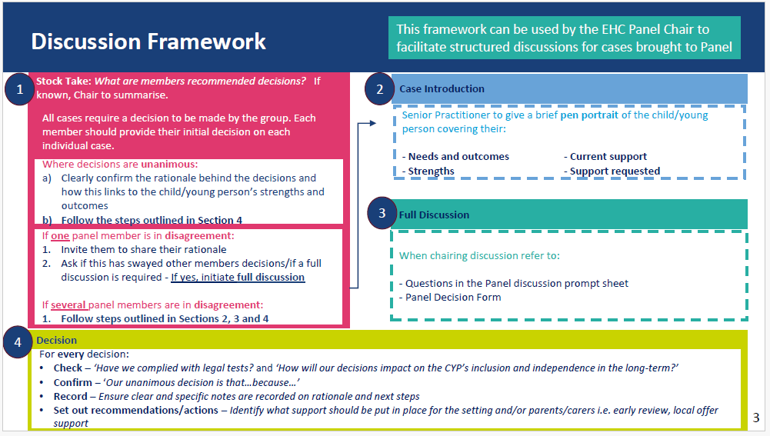
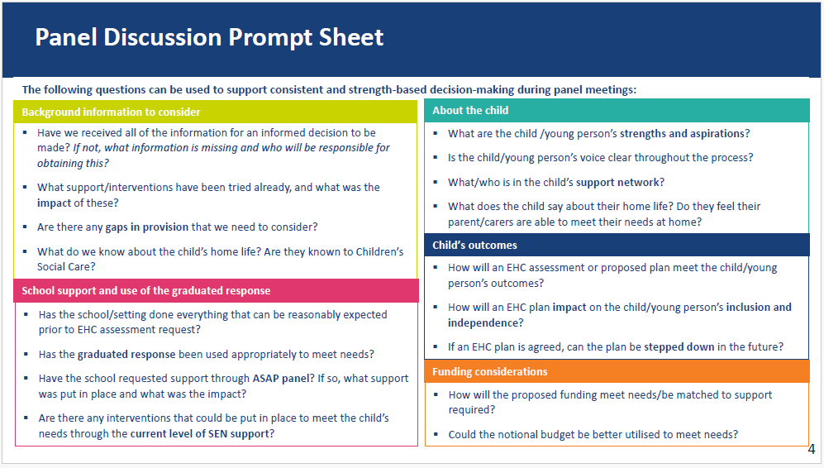
Descriptors of Need and funding discussion
- Up to range 3 - no assessment.
- Range 4 equates to B, C and D funding.
- Range 5/6 equates to those who require a higher level of funding 1-1 or a support, small groups, support with environment or a potential specialist school.

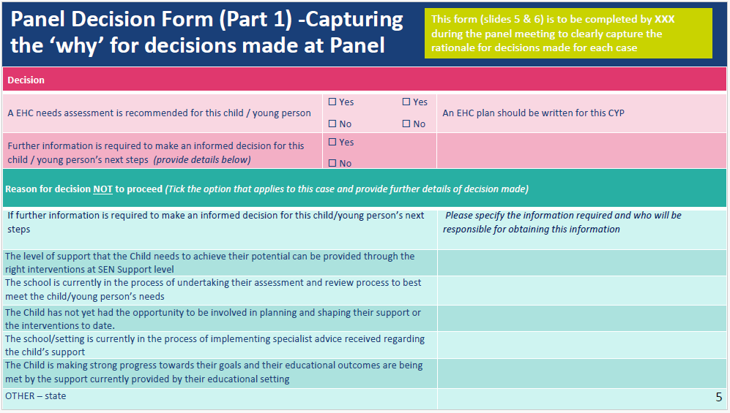

Appendix 5 – EOTAS Checklist

EOTAS
Childrens and Families Act 2014 Section 61 states:
(1) A local authority in England may arrange for any special educational provision that it has decided is necessary for a child or young person for whom it is responsible to be made otherwise than in a school or post-16 institution or a place at which relevant early years education is provided.
(2) An authority may do so only if satisfied that it would be inappropriate for the provision to be made in a school or post-16 institution or at such a place.
(3) Before doing so, the authority must consult the child's parent or the young person.
Evidence required when the inclusion panel are considering agreeing/disagreeing EOTAS.
(EOTAS cannot be agreed solely due to a child/young person’s non-attendance to school)

Evidence provided | Yes | No | Notes
Proposed/draft EHCP
Annual review minutes
Reason for EOTAS request
Professional reports
Access, Plan, Do, Review
Evidence of steps taken in providing support for EBSNA (early review, SENASAP support etc)
Parent/pupil views
Evidence of schools responses indicating no school can meet need

Appendix 6 - High Needs Funding Form – Annex 1

HNF Annex 1 2024-2025

